SIMATS ENGINEERING
ASSESSMENT TOOL 1

COURSE NAME: Artificial Intelligence COURSE CODE: CSA17

COURSE OUTCOME COVERED

CO1: Apply AI basics such as intelligent agents and uninformed search methods to solve problems effectively. (BL3)

Assessment Tool Weightage: 50%

QUESTIONS: 5 Duration : 1 Hour
Total Marks:50

Annexure A

Analytical Problem Solving

Code of Conduct:

I Patteela Yashwanth Kumar/192471055(Name / Reg No) certify that this submission is my original work and that I have adhered to the guidelines specified for this assessment.
I understand that any violation of academic integrity rules will result in disciplinary action.

Signature of the student:
Patteela Yashwanth Kumar

Annexure A

Analytical Problem Solving

- Solve the Water Jug problem: you are given 2 jugs, a 4-gallon one and 3-gallon one. Neither has any measuring maker on it. There is a pump that can be used to fill the jugs with water. How can you get exactly 2 gallons of water into 4-gallon jug? Explicit assumptions: A jug can be filled from the pump, water can be poured out of a jug onto the ground, water can be poured from one jug to another and that there are no other measuring devices available.

- Find out how Mars Rover, analyse and explore the samples on Mars by answering the following questions.
- What are the percept’s for this agent?
- Characterize the operating environment.
- What are the actions the agent can take?
- How can one evaluate the performance of the agent?
- What sort of agent architecture do you think is most suitable for this agent? Why?

- Explore the search space using search strategies and formulate the problem components for the 8-Queens problem using the following information: Place 8 queens on a chessboard such that none of the queen’s attack any of the others. A configuration of 8 queens on the board as shown in the figure below, but this does not represent a solution as the queen in the first column is on the same diagonal as the queen in the last column.

- A customer wants to travel from the one location to another location using OLA Cab booking mobile application. The customer can select the any of the cab type as mini, micro, sedan, shared, prime and so on based on his comfort to reach the destination. Identify what type of problem-solving agent can be used and write the pseudocode for the above problem.

- A logistics company operates a delivery network where packages must be transported between warehouses at minimum cost. Each route between warehouses has an associated travel cost (fuel + time). The company wants to determine the least-cost path from the starting warehouse S to the destination warehouse G using the Uniform Cost Search (UCS) algorithm.
The delivery network is represented as a weighted graph:

RUBRICS FOR CALCULATION:
Criteria | Weightage | Level 4 (Exemplary) | Level 3 (Proficient) | Level 2 (Developing) | Level 1 (Beginning)
Problem Understanding | 20% | Clearly interprets problem, identifies all parameters and requirements accurately | Understands problem with minor gaps | Partial understanding; misses key elements | Misinterprets or unable to understand problem
Method Selection | 20% | Selects most appropriate method/formula with strong justification | Selects correct method with minor errors | Inappropriate or partially correct method | Unable to select method
Solution Process | 25% | Logical, systematic steps with correct approach throughout | Mostly correct steps with minor mistakes | Disorganized steps; multiple errors | No clear process
Accuracy of Calculation | 20% | All calculations accurate; correct final answer | Minor calculation errors | Frequent errors; incorrect final answer | No valid calculations
Interpretation of Results | 15% | Clearly interprets results with units and engineering relevance | Basic interpretation with minor omissions | Limited or unclear interpretation | No interpretation
Problem Understanding | 20% | Clearly interprets problem, identifies all parameters and requirements accurately | Understands problem with minor gaps | Partial understanding; misses key elements | Misinterprets or unable to understand problem

QUESTION 1 – Water Jug Problem

Problem Understanding: We have a 4-gallon jug and a 3-gallon jug, with no measuring marks. We can fill a jug from the pump, empty a jug onto the ground, and pour water from one jug into the other. The objective is to obtain exactly 2 gallons in the 4-gallon jug.
Method Selection – State-Space Search
The problem can be represented as a state-space search problem. A state is represented as (x, y), where x is the amount of water in the 4-gallon jug and y is the amount in the 3-gallon jug. The initial state is (0,0), and a goal state is any state with x = 2.
The permitted operations are filling either jug, emptying either jug, and pouring water from one jug into the other until either the source is empty or the destination is full. The search avoids unnecessary repetition of states.
Step-by-Step Solution
Step | Operation | 4-Gallon | 3-Gallon | State
0 | Initial state | 0 | 0 | (0,0)
1 | Fill 3-gallon jug | 0 | 3 | (0,3)
2 | Pour 3 → 4 | 3 | 0 | (3,0)
3 | Fill 3-gallon jug | 3 | 3 | (3,3)
4 | Pour 3 → 4 until 4-gallon is full | 4 | 2 | (4,2)
5 | Empty 4-gallon jug | 0 | 2 | (0,2)
6 | Pour 3 → 4 | 2 | 0 | (2,0)
At Step 6, the 4-gallon jug contains exactly 2 gallons, so the goal condition is satisfied.
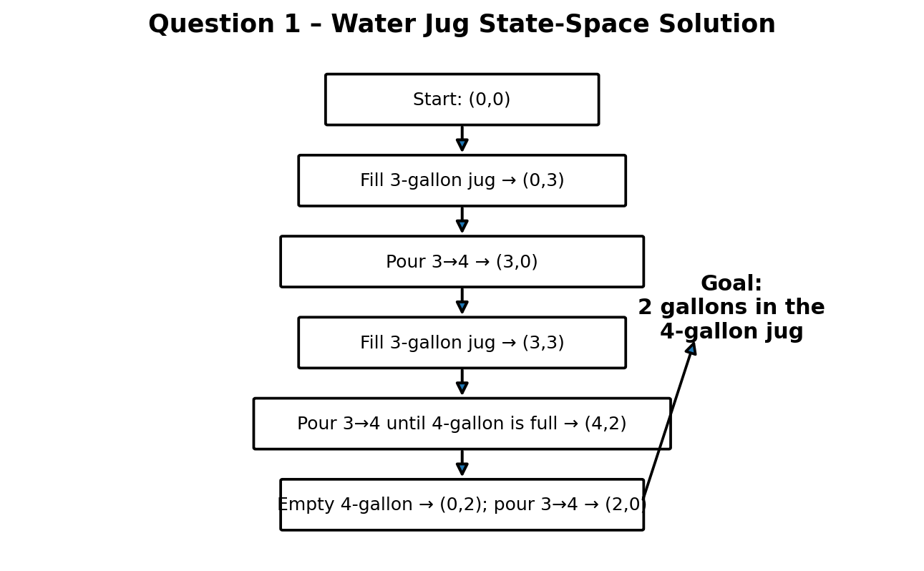
Justification / Rationality
The state-space approach is appropriate because every action changes the two jug quantities in a predictable way. Each state records exactly how much water is available, and the sequence of legal actions can be checked against the goal condition. The solution reaches the required quantity without any measuring device and follows all assumptions given in the question.
Conclusion
The Water Jug problem is successfully solved through state-space search. Starting from (0,0), the sequence of six operations reaches the goal state (2,0), meaning that exactly 2 gallons are present in the 4-gallon jug.Water Jug problem is successfully solved using state-space search. Starting from the initial state (0,0), a sequence of valid filling, pouring, and emptying operations leads to the state (2,0). Thus, exactly 2 gallons of water are obtained in the 4-gallon jug without using any measuring device. The solution demonstrates how AI search techniques can systematically solve problems by exploring valid states and selecting actions that lead to the desired goal
QUESTION 2 – Mars Rover Intelligent Agent
Problem Understanding: The Mars Rover is an intelligent agent that must perceive its surroundings, analyse scientific samples, navigate uncertain terrain, conserve resources and communicate useful information. Its decisions should support both safe exploration and scientific objectives.
i. Percepts of the Agent
• Camera images showing rocks, terrain, slopes and obstacles.
• Spectrometer and sample-analysis measurements.
• Position, orientation, wheel movement and terrain-contact information.
• Temperature, radiation, dust and other environmental measurements.
• Battery level, communication status and available resources.
• Sample properties and scientific analysis results.
• Commands and updated mission information from the control station.
ii. Characterize the Operating Environment
The Mars Rover operates in a partially observable, uncertain, sequential, dynamic and largely unknown environment. It cannot directly observe the whole surroundings and must infer hidden conditions from sensor data. The environment is also resource-constrained because energy, communication opportunities and mission time are limited. It is primarily a single-agent environment, with indirect cooperation from human mission controllers.
iii. Actions the Agent Can Take
• Move forward, reverse, turn and select a safe route.
• Stop or change direction when an obstacle or unsafe surface is detected.
• Drill, collect and handle rock or soil samples.
• Analyse samples using scientific instruments.
• Store, process and transmit scientific data.
• Monitor and manage energy consumption.
• Change priorities or postpone activities when conditions are unsafe.
iv. Performance Evaluation
Performance can be evaluated using scientific data quality, number and quality of samples analysed, area explored, navigation safety, energy efficiency, communication reliability, mission completion rate and the usefulness of information returned to Earth. A strong agent should maximize scientific value while minimizing risk, energy consumption and unnecessary travel.
v. Suitable Agent Architecture and Reason
A model-based, utility-based intelligent agent is most suitable. The model-based component is needed because the rover cannot observe everything directly and must maintain an internal state of the environment. The utility-based component helps it balance competing objectives such as scientific value, safety, energy, travel distance and communication opportunities.
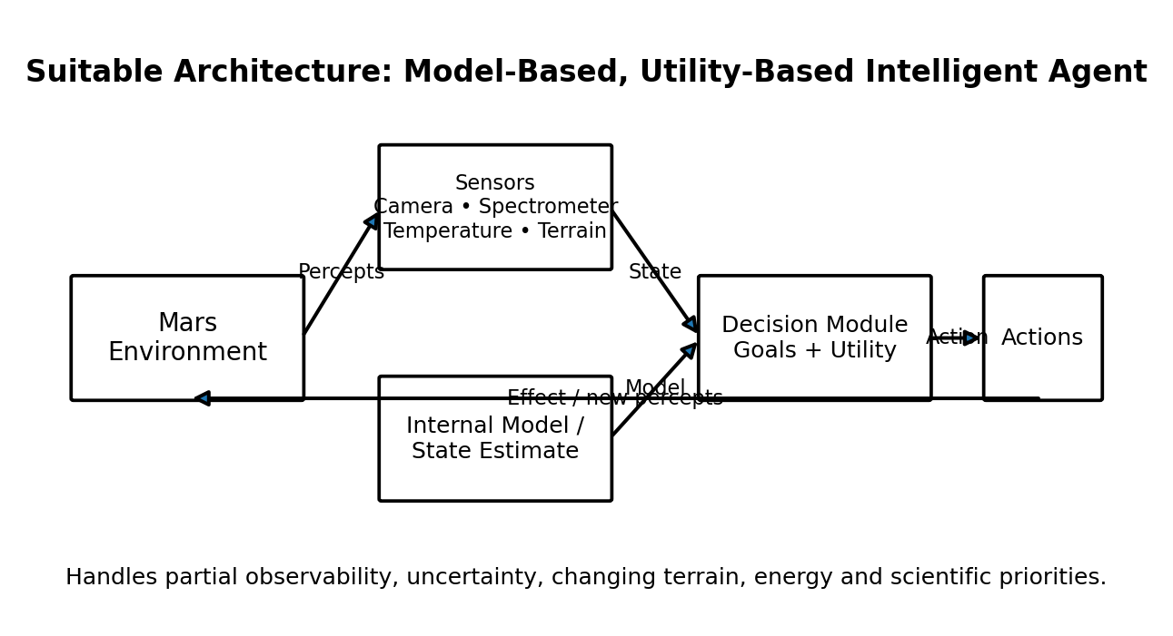
Justification / Rationality
This architecture allows the rover to make decisions when the environment is only partially observable. By maintaining an internal model and comparing the utility of possible actions, it can choose a safe and scientifically valuable activity. This is more suitable than a simple reflex agent because Mars exploration requires memory, planning and decision-making under uncertainty.
Conclusion
The Mars Rover can be modelled as an intelligent agent that senses, reasons, acts and evaluates its performance. A model-based and utility-based architecture provides the flexibility required for autonomous exploration, sample analysis, resource management and safe navigation.
In conclusion, the Mars Rover can be effectively designed as an intelligent agent that perceives its environment, processes information, takes suitable actions, and evaluates its performance. A model-based and utility-based agent architecture is suitable because the rover operates in a partially observable and uncertain environment. It can maintain an internal model, consider safety and scientific objectives, and select appropriate actions. Thus, the Mars Rover can explore the environment, analyse samples, manage resources, and achieve its mission objectives effectively.

QUESTION 3 – 8-Queens Problem
Problem Understanding: The objective is to place eight queens on an 8×8 chessboard so that no two queens attack each other. Two queens attack each other when they occupy the same row, the same column or the same diagonal.
Problem Formulation
- Initial State: Empty 8×8 chessboard.
- State Representation: A partial configuration of queens, represented by the selected row for each occupied column.
- Actions: Place a queen in the next unoccupied column in a row that does not conflict with existing queens.
- Transition Model: Adding one non-conflicting queen produces a new state.
- Goal Test: Eight queens are placed and no two queens share a row, column or diagonal.
- Path Cost: Each placement may be treated as unit cost; the main objective is to reach a valid goal state.
Search Strategy
Backtracking depth-first search is suitable because queens can be placed one column at a time. If a partial configuration violates a constraint, it is immediately rejected. When no valid row remains for a column, the algorithm backtracks to the previous column and tries another position.
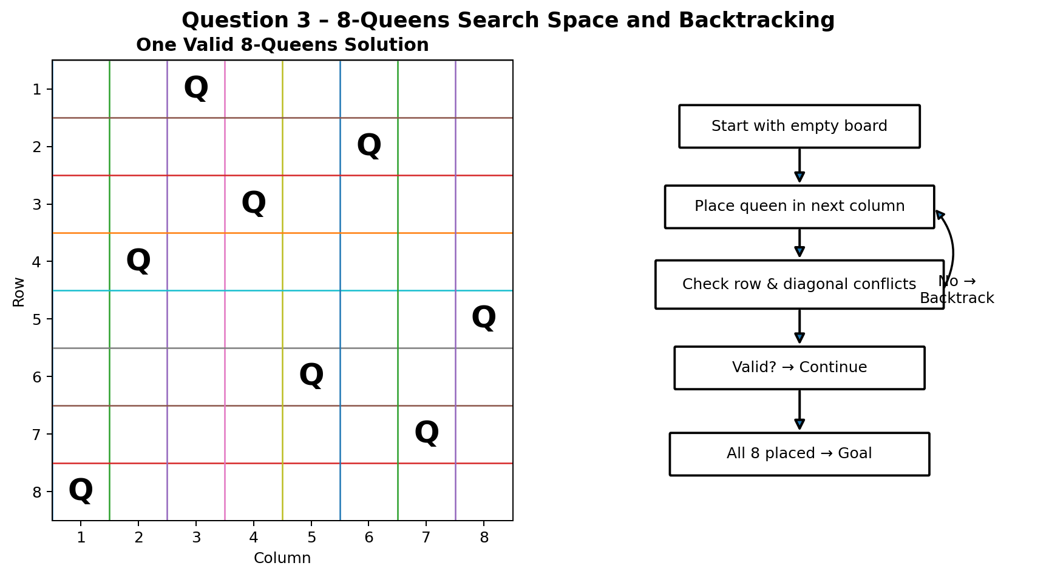
Example Valid Configuration
One valid solution is represented by the row sequence [1, 5, 8, 6, 3, 7, 2, 4], where the ith value gives the row of the queen in column i. This configuration satisfies the row, column and diagonal constraints.
Justification / Rationality
Backtracking is rational because it applies the constraints during the search instead of generating every complete board first. Invalid partial states are discarded immediately, reducing unnecessary exploration.
Conclusion
The 8-Queens problem is a classic search and constraint problem. By representing partial placements as states and using backtracking to eliminate conflicting configurations, a valid arrangement can be obtained systematicalthe
QUESTION 4 – OLA Cab Booking Problem
Problem Understanding: A customer wants to travel from a source location to a destination using the OLA Cab mobile application. The customer can choose among cab types such as mini, micro, sedan, shared and prime. The choice can depend on fare, estimated arrival time, comfort, availability and personal preference.
Type of Problem-Solving Agent
A utility-based problem-solving agent is most suitable. A goal-based agent mainly checks whether the destination can be reached, while a utility-based agent can compare several feasible cab choices and select the one that provides the highest overall utility according to customer preferences.
Possible Utility Factors
• Lower fare can increase utility.
• Shorter estimated arrival time can increase utility.
• Higher comfort can increase utility.
• Availability and reliability can be considered.
• Customer preferences can be assigned higher weight.
• The selected cab must still satisfy the basic travel goal.
Pseudocode
BEGIN
Read source location
Read destination location
Read customer preferences
Get available cab types
FOR each available cab
Get fare
Get estimated arrival time
Get comfort level
Calculate utility score
END FOR
Remove cabs that do not satisfy requirements
Select cab with highest utility score
Display cab type, fare and estimated time
Ask customer for confirmation
IF customer confirms THEN
Book the selected cab
ELSE
Allow another cab choice
END IF
END
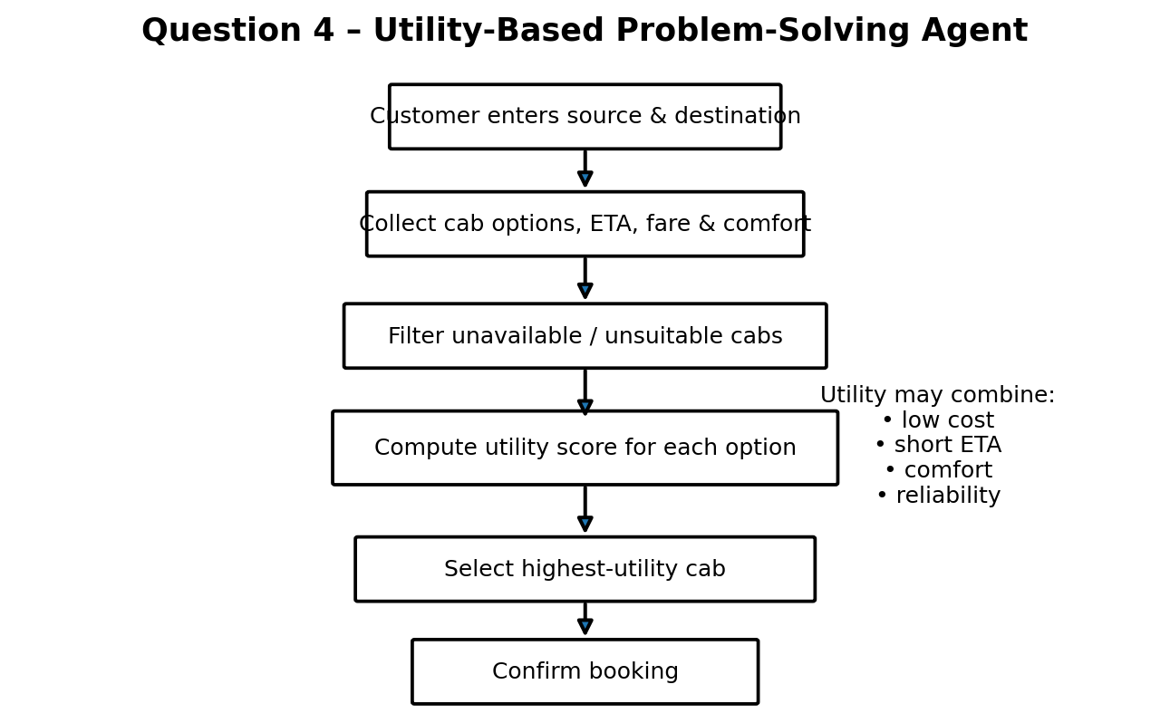
Justification / Rationality
The utility-based approach is rational because several cab choices may satisfy the basic travel goal. The agent compares the alternatives using relevant factors and selects the option that best satisfies the customer's overall preference. This supports flexible decision-making rather than simply selecting the first available cab.
Conclusion
The OLA cab selection problem can be handled effectively by a utility-based problem-solving agent. The agent evaluates available cabs, calculates their utility and recommends the option that best balances fare, arrival time, comfort and customer requirements.
QUESTION 5 – Uniform Cost Search for Minimum-Cost Delivery
Problem Understanding: The logistics network is a weighted graph in which every route has an associated travel cost. The objective is to find the least-cost path from starting warehouse S to destination warehouse G. From the graph in the question, the relevant directed routes and costs are S→A (1), A→B (3), B→D (3), D→G (3), A→C (1), C→D (1), C→G (2), and S→G (12).
Method Selection – Uniform Cost Search
Uniform Cost Search is appropriate because the objective is to minimize cumulative route cost. UCS expands the node with the smallest path cost g(n) from the start and uses a priority queue ordered by cumulative cost. With non-negative route costs, the first time the goal is selected for expansion, the resulting path is optimal.
UCS Calculation
Step | Expanded Node | Cumulative Cost | Priority Queue After Expansion
1 | S | 0 | A(1), G(12)
2 | A | 1 | C(2), B(4), G(12)
3 | C | 2 | D(3), G(4), B(4), G(12)
4 | D | 3 | G(4), B(4), G(6)
5 | G | 4 | Goal reached – stop
The important candidate routes are: S→A→C→G = 1+1+2 = 4; S→A→C→D→G = 1+1+1+3 = 6; S→A→B→D→G = 1+3+3+3 = 10; and direct S→G = 12. Therefore, the minimum is 4.
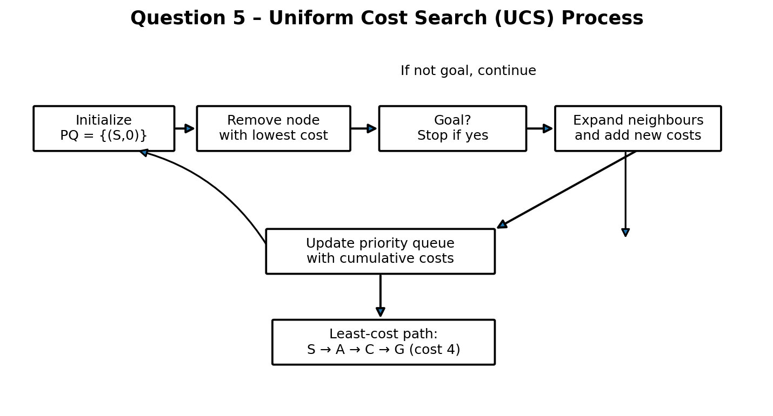
Least-Cost Path
S → A → C → G
Minimum total cost = 1 + 1 + 2 = 4
Justification / Interpretation
UCS is the correct method because the routes have different costs and the company wants the minimum total cost rather than simply the minimum number of edges. The algorithm always expands the currently cheapest cumulative path. In this graph, the goal is reached with cost 4, which is lower than every other complete route.
Conclusion
Uniform Cost Search identifies S→A→C→G as the least-cost delivery path with total cost 4. The result demonstrates how UCS can support cost-efficient logistics routing when route costs are non-uniform (UCS) successfully determines the least-cost path from the starting warehouse S to the destination G. By expanding the node with the lowest cumulative cost, UCS identifies the optimal route S → A → C → G with a minimum total cost of 4.

